Level 1: Coursework 4
2015-16
Section A: The pictures below indicate the country where the person/people are from. Using the example below as a template, form questions and answers to describe the people in each picture. (50 marks: 5 X 10)

(Saudi Arabia) (Bahrain)
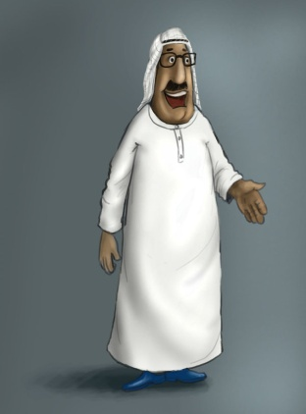
هو من أين؟
هو من البحرين. هو بحريني.
(Egypt) (Japan)
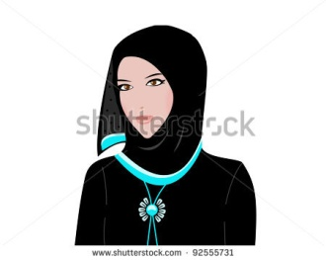

(England) (Russia)


Section B: You are in an Arab country and planning a birthday party which will be attended by 6 friends and some family members.

Make a list of 10 party and food items you intend to buy, including the number (or kilos) of each, and the material they are made of, when applicable. (50 marks: 10 X 5)

