TASK: Open the file HO.xls. In it, the velocity-Verlet algorithm is used to model the behaviour of a classical harmonic oscillator. Complete the three columns "ANALYTICAL", "ERROR", and "ENERGY": "ANALYTICAL" should contain the value of the classical solution for the position at time , "ERROR" should contain the absolute difference between "ANALYTICAL" and the velocity-Verlet solution (i.e. ERROR should always be positive -- make sure you leave the half step rows blank!), and "ENERGY" should contain the total energy of the oscillator for the velocity-Verlet solution. Remember that the position of a classical harmonic oscillator is given by (the values of , , and are worked out for you in the sheet).
See attached excel spreadsheet.
TASK: For the default timestep value, 0.1, estimate the positions of the maxima in the ERROR column as a function of time. Make a plot showing these values as a function of time, and fit an appropriate function to the data.
See attached excel spreadsheet.

TASK: Experiment with different values of the timestep. What sort of a timestep do you need to use to ensure that the total energy does not change by more than 1% over the course of your "simulation"? Why do you think it is important to monitor the total energy of a physical system when modelling its behaviour numerically?

According to Newton’s Laws of motion, the total momentum and energy of the system should be conserved during the simulation. If the total energy of the system changes during the simulation, this means that the model used is not appropriate and it will not produce reliable or accurate results. A timestep of 0.6 or less is adequate to ensure that the energy does not change by more than 1% over the course of the simulation.

TASK: For a single Lennard-Jones interaction, 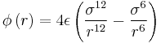, find the separation, , at which the potential energy is zero. What is the force at this separation? Find the equilibrium separation, , and work out the well depth (). Evaluate the integrals 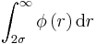, 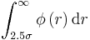, and 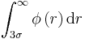when .

At r₀, Φ(r) = 0. Therefore:
$$0= \frac{σ^{12}}{r_{0}^{12}}- \frac{σ^{6}}{r_{0}^{6}}$$
$$σ^{6}= r_{0}^{6}$$
$$σ= r_{0}$$

At r_{eq}, $\frac{dΦ(r)}{dr}=0$
$$\frac{dΦ(r)}{dr}=4ε\left(\frac{-12σ^{12}}{r^{13}}+\frac{6σ^{6}}{r^{7}}\right)=0$$
$$r^{6}=2σ^{6}$$
$$r_{eq}= \sqrt[6]{2}σ$$

$$Φ\left(r_{eq}\right)=4ε(\frac{σ^{12}}{{\left(\sqrt[6]{2}σ\right)}^{12}}- \frac{σ^{6}}{{\left(\sqrt[6]{2}σ\right)}^{6}})$$
$$Φ\left(r_{eq}\right)=4ε(\frac{1}{4}-\frac{1}{2})$$
$$Φ\left(r_{eq}\right)=-ε$$

$$\int_{2σ, 2.5σ, 3σ}^{∞}{Φ\left(r\right)dr= \int_{2σ, 2.5σ, 3σ}^{∞}{4ε(\frac{σ^{12}}{r^{12}}-\frac{σ^{6}}{r^{6}})dr}}$$

When σ = ε = 1.0:
$$\int_{2σ, 2.5σ, 3σ}^{∞}{Φ\left(r\right)dr}=4\int_{2σ, 2.5σ, 3σ}^{∞}{\frac{1}{r^{12}}-\frac{1}{r^{6}} dr}$$

$$\int_{2σ, 2.5σ, 3σ}^{∞}{Φ\left(r\right)dr=4[-\frac{1}{11r^{11}}+ \frac{1}{5r^{5}}]_{2σ,2.5σ,3σ}^{∞}}$$
At r = 2σ, Φ(r) = -0.02482 eV
At r = 2.5σ, Φ(r) = -0.00817 eV
At r = 3σ, Φ(r) = -0.00329 eV

TASK: Estimate the number of water molecules in 1ml of water under standard conditions. Estimate the volume of water molecules under standard conditions.
1g H₂O in 1ml:
1g H₂O = 0.0555 mol x 6.022x10²³ mol⁻¹ = 3.345x10²² molecules in 1 ml H₂O
10000 molecules = 10000 /6.022x10²³ = 1.66x10⁻²⁰ mol x 18 g/mol = 2.989x10⁻¹⁹ g.
1 = 2.989x10⁻¹⁹ / V
V of 10000 molecules of H₂O = 2.989x10⁻¹⁹ cm⁻³

TASK: Consider an atom at position in a cubic simulation box which runs from to . In a single timestep, it moves along the vector . At what point does it end up, after the periodic boundary conditions have been applied?.
When periodic boundary conditions are applied, if the atom reaches the end of the box, it will be transferred back to the beginning. Therefore the atom will end up in the position (0.2, 0.1, 0.7).

TASK: The Lennard-Jones parameters for argon are . If the LJ cutoff is , what is it in real units? What is the well depth in ? What is the reduced temperature in real units?
r = r* x σ = 3.2x0.34 = 1.088 nm
E = 120x1.38064852⁻²³ = 1.656*10⁻²⁴ KJ * 6.022x10^23 = 0.9977 KJ/mol
T = 1.5x120 = 180K

TASK: Why do you think giving atoms random starting coordinates causes problems in simulations? Hint: what happens if two atoms happen to be generated close together?
When atoms are generated very close to each other, interatomic potentials and forces between the atoms will be computed to be large which will result in large energy values and hence the value obtained for the energy will not be accurate since the structure is not optimised before measuring the energy. Structure and energy optimisations are necessary before performing molecular dynamics to the system. In this case, the fix nve/limit command was used to optimise the structure, and the atoms were generated using the create_atoms command with multiple periodic lattices to ensure that there are no overlapping atoms at the box boundaries.

TASK: Satisfy yourself that this lattice spacing corresponds to a number density of lattice points of . Consider instead a face-centred cubic lattice with a lattice point number density of 1.2. What is the side length of the cubic unit cell?

Atom mass = 1.0 reduced units
Cell Volume = (1.07722)³ = 1.25 reduced units
Density = 1/1.25 = 0.8 reduced units
FCC has 4 atoms per lattice cell.
1.2 = 4/V, V= 3.33 reduced units
Side length = 3.33^{1/3} =1.49 reduced units

TASK: Consider again the face-centred cubic lattice from the previous task. How many atoms would be created by the create_atoms command if you had defined that lattice instead?

40³ = 64000 atoms

TASK: Using the LAMMPS manual, find the purpose of the following commands in the input script:
mass 1 1.0
pair_style lj/cut 3.0
pair_coeff * * 1.0 1.0

The mass command sets the mass of all the atoms in the simulation. 1 corresponds to the type of atom. (in this case only one type of atom is used so all atoms are of type 1). 1.0 is the value set to the mass.
The pair_style lj command instructs a Leonard-Jones interaction between atoms and cut 3.0 sets the global cutoff for Lennard Jones interactions (distance). Atoms with a distance greater than 3.0 reduced units are considered to not interact with each other.

The pair_coeff command specifies the forcefield coefficients for one or more pairs of atom types. The first two arguments define the type of atoms, in this case an asterisk is used, instructing to apply the forcefield for all types of atoms. The two 1.0 arguments that follow specify the forcefield values for these atoms.

TASK: Given that we are specifying and , which integration algorithm are we going to use?

Velocity-Verlet algorithm

TASK: Look at the lines below.
### SPECIFY TIMESTEP ###
variable timestep equal 0.001
variable n_steps equal floor(100/${timestep})
timestep ${timestep}

### RUN SIMULATION ###
run ${n_steps}
run 100000
The second line (starting "variable timestep...") tells LAMMPS that if it encounters the text ${timestep} on a subsequent line, it should replace it by the value given. In this case, the value ${timestep} is always replaced by 0.001. In light of this, what do you think the purpose of these lines is? Why not just write:
timestep 0.001
run 100000

The purpose of these lines is to maintain the same timestep throughout the simulation. Since LAMMPS reads the code one line at a time, if the timestep changes later in the code, it will be replaced by the new value. By defining and forcing a timestep throughout the calculation, a constant timestep is ensured. Also, this command can save a lot of time by just calling the variable every time it is needed rather than having to write the actual value of the timestep every time.

TASK: make plots of the energy, temperature, and pressure, against time for the 0.001 timestep experiment (attach a picture to your report). Does the simulation reach equilibrium? How long does this take? When you have done this, make a single plot which shows the energy versus time for all of the timesteps (again, attach a picture to your report). Choosing a timestep is a balancing act: the shorter the timestep, the more accurately the results of your simulation will reflect the physical reality; short timesteps, however, mean that the same number of simulation steps cover a shorter amount of actual time, and this is very unhelpful if the process you want to study requires observation over a long time. Of the five timesteps that you used, which is the largest to give acceptable results? Which one of the five is a particularly bad choice? Why?

Answered in the report (See Results and Discussion section)

TASK: Choose 5 temperatures (above the critical temperature ), and two pressures (you can get a good idea of what a reasonable pressure is in Lennard-Jones units by looking at the average pressure of your simulations from the last section). This gives ten phase points — five temperatures at each pressure. Create 10 copies of npt.in, and modify each to run a simulation at one of your chosen points. You should be able to use the results of the previous section to choose a timestep. Submit these ten jobs to the HPC portal. While you wait for them to finish, you should read the next section.

Answered in the report (See Method section).

TASK: We need to choose so that the temperature is correct if we multiply every velocity . We can write two equations:
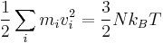
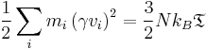
Solve these to determine .

When , the left-hand sides of both equations must be equal. By observation, the value at which this is true is when γ = 1.

Now look at the lines near the end of the file:
### MEASURE SYSTEM STATE ###
thermo_style custom step etotal temp press density
variable dens equal density
variable dens2 equal density*density
variable temp equal temp
variable temp2 equal temp*temp
variable press equal press
variable press2 equal press*press
fix aves all ave/time 100 1000 100000 v_dens v_temp v_press v_dens2 v_temp2 v_press2
run 100000

TASK: Use the manual page to find out the importance of the three numbers 100 1000 100000. How often will values of the temperature, etc., be sampled for the average? How many measurements contribute to the average? Looking to the following line, how much time will you simulate?
Use input values every 100 timesteps. Use input values to calculate averages every 1000 timesteps. Calculate averages every 100000 timesteps. Since the simulation will proceed for 100000 timesteps, the average thermodynamic properties of the system will be calculated once. The timestep is 0.0025 ps and 100000 steps will be simulated therefore the total simulation time is 0.0025x100000 = 250 ps.

TASK: When your simulations have finished, download the log files as before. At the end of the log file, LAMMPS will output the values and errors for the pressure, temperature, and density 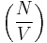. Use software of your choice to plot the density as a function of temperature for both of the pressures that you simulated. Your graph(s) should include error bars in both the x and y directions. You should also include a line corresponding to the density predicted by the ideal gas law at that pressure. Is your simulated density lower or higher? Justify this. Does the discrepancy increase or decrease with pressure?

Answered in the report (See Results and Discussion section). Error bars were plotted in both directions but some are very small and might not be easily visible.

TASK: As in the last section, you need to run simulations at ten phase points. In this section, we will be in density-temperature phase space, rather than pressure-temperature phase space. The two densities required at and , and the temperature range is . Plot as a function of temperature, where is the volume of the simulation cell, for both of your densities (on the same graph). Is the trend the one you would expect? Attach an example of one of your input scripts to your report.

Answered in the report (See Method, Results and Discussion sections).

TASK: perform simulations of the Lennard-Jones system in the three phases. When each is complete, download the trajectory and calculate and 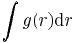. Plot the RDFs for the three systems on the same axes, and attach a copy to your report. Discuss qualitatively the differences between the three RDFs, and what this tells you about the structure of the system in each phase. In the solid case, illustrate which lattice sites the first three peaks correspond to. What is the lattice spacing? What is the coordination number for each of the first three peaks?

Answered in the report (See Method, Results and Discussion sections).
FCC lattice parameter calculation (lattice parameter = 2a):
Using Pythagoras’s theorem:
(distance of first peak)² = 2a²
1.025² = 2a²
a= 0.7247 Å
2a = 1.45Å
TASK: In the D subfolder, there is a file liq.in that will run a simulation at specified density and temperature to calculate the mean squared displacement and velocity autocorrelation function of your system. Run one of these simulations for a vapour, liquid, and solid. You have also been given some simulated data from much larger systems (approximately one million atoms). You will need these files later.

Answered in the report (See Method section).

TASK: make a plot for each of your simulations (solid, liquid, and gas), showing the mean squared displacement (the "total" MSD) as a function of timestep. Are these as you would expect? Estimate in each case. Be careful with the units! Repeat this procedure for the MSD data that you were given from the one million atom simulations.

Answered in the report (See Results and Discussion section).
Plots for MSD for 1000000 atoms not included in the report and are shown here:
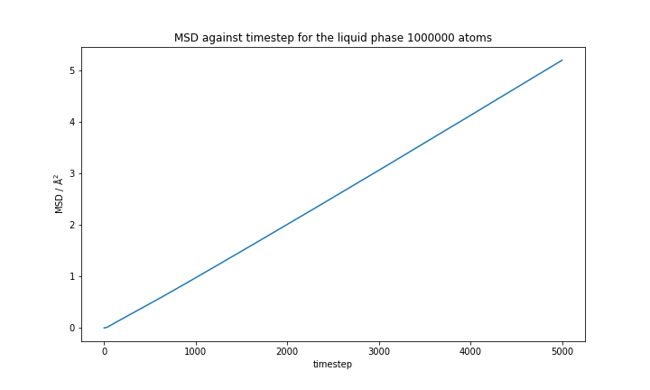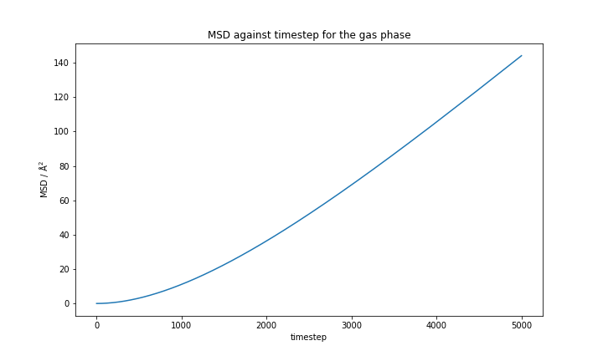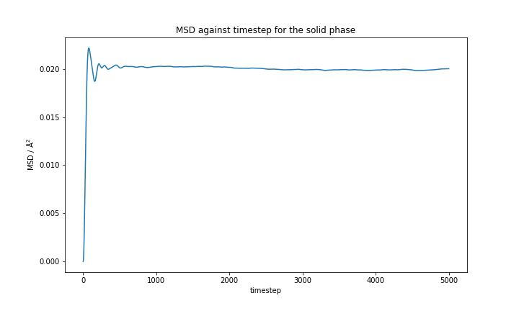

TASK: In the theoretical section at the beginning, the equation for the evolution of the position of a 1D harmonic oscillator as a function of time was given. Using this, evaluate the normalised velocity autocorrelation function for a 1D harmonic oscillator (it is analytic!):
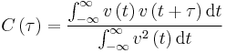
Be sure to show your working in your writeup. On the same graph, with x range 0 to 500, plot with and the VACFs from your liquid and solid simulations. What do the minima in the VACFs for the liquid and solid system represent? Discuss the origin of the differences between the liquid and solid VACFs. The harmonic oscillator VACF is very different to the Lennard Jones solid and liquid. Why is this? Attach a copy of your plot to your writeup.
Normalised velocity autocorrelation function:
$$x=Acos(ωt+Φ)$$
$$v= \frac{dx}{dt}=-Αωsin⁡(ωt+Φ)$$
$$C\left(t\right)= \frac{\int_{-∞}^{∞}{A^{2}ω^{2}\sin\left(ωt+Φ\right)*\sin\left(ω\left(t+τ\right)+Φ\right)dt}}{\int_{-∞}^{∞}{Α^{2}ω^{2}\sin^{2}\left(ωt+Φ\right) dt}}$$

Denominator:
$$\int_{-∞}^{∞}{Α^{2}ω^{2}\sin^{2}\left(ωt+Φ\right) dt}=\int_{-∞}^{∞}{Α^{2}ω^{2}\frac{1-cos\left(2ωt+2Φ\right)}{2} dt}=\frac{1}{2}A^{2}ω^{2}\int_{-∞}^{∞}{dt - }\frac{1}{2}A^{2}ω^{2}\int_{-∞}^{∞}{\cos\left(2ωt+2Φ\right)dt}$$
Evaluating the integral for the denominator:
$$\frac{1}{2}A^{2}ω^{2}\left[t- \frac{1}{2ω}sin⁡(2\left(ωt+Φ\right))\right]\begin{matrix}∞ \\ -∞\end{matrix}$$
At -∞ and ∞ , sin is 0, therefore this is simplified to:
$$\frac{1}{2}A^{2}ω^{2}t$$

Numerator:
$$\int_{-∞}^{∞}{A^{2}ω^{2}\sin\left(ωt+Φ\right)*\sin\left(ω\left(t+τ\right)+Φ\right)dt}$$

Using sin(a+b) = sin(a)cos(b)-sin(b)cos(a), where a = ωt and b = ωτ:
$$\int_{-∞}^{∞}{A^{2}ω^{2}\sin\left(ωt+Φ\right)*(sin\left(ωt+Φ\right)\cos\left(ωτ\right)-\cos\left(ωt+Φ\right)sin⁡(ωτ))dt}$$
$${=A}^{2}ω^{2}\cos\left(ωτ\right)\int_{-∞}^{∞}{\sin^{2}\left(ωt+Φ\right)dt -{A^{2}ω^{2}\sin\left(ωτ\right)\int_{-∞}^{∞}{sin⁡(ωt+Φ)}cos\left(ωt+Φ\right)}dt}$$

From the solution above:
$$A^{2}ω^{2}\cos\left(ωτ\right)\int_{-∞}^{∞}{\sin^{2}\left(ωt+Φ\right)dt=\frac{A^{2}ω^{2}\cos\left(ωτ\right)}{2} \left[t-\frac{1}{2ω}\sin\left(2ωt+Φ\right)\right]}\begin{matrix}∞ \\ -∞\end{matrix}=\frac{A^{2}ω^{2}\cos\left(ωτ\right)}{2}t$$

Using integration by parts:
$$\frac{Α^{2}ω^{2}sin(ωτ)}{2}\int_{-∞}^{∞}{\sin\left(ωt+Φ\right)cos(ωt+Φ)dt}= \frac{Α^{2}ωsin(ωτ)}{2}\int_{-∞}^{∞}{u du}$$

Where u = sin(ωt+Φ), du/dt = ωcos(ωt+Φ)
Evaluating the integral:
$$\frac{Α^{2}ωsin(ωτ)}{2}\left[\sin^{2}(ωt+Φ)\right]\begin{matrix}∞ \\ -∞\end{matrix}$$
At -∞, ∞, sin is 0 which simplifies to 0.
Putting the parts together:
$$C\left(t\right)= \frac{\frac{A^{2}ω^{2}\cos\left(ωτ\right)*t}{2}}{\frac{A^{2}ω^{2}t}{2}}=cos⁡(ωτ)$$

Answered in the report (See Results and Discussion section).

TASK: Use the trapezium rule to approximate the integral under the velocity autocorrelation function for the solid, liquid, and gas, and use these values to estimate in each case. You should make a plot of the running integral in each case. Are they as you expect? Repeat this procedure for the VACF data that you were given from the one million atom simulations. What do you think is the largest source of error in your estimates of D from the VACF?

Errors discussed in the report. Evaluation of the integrals:
Trapezium rule: the area under the curve from point x₀ to x_{n} is given by:
h/2*((y₀+y_{n} +2*(y₁+y₂+…+y_{n-1}))
where h= (b-a)/n
h = distance (in terms of x) between the strips
b = upper integration limit
a = lower integration limit
n = number of trapeziums the curve is split to

Gas phase with 8000 and 1000000 molecules:

Both graphs evaluated with h = 200

AUC divided by 3 (8000 atoms) = 1783.432 angstroms squared per timestep = 3.566864 angstroms squared/ps = 3.566864x10⁻⁸ m²/s
AUC divided by 3 (1000000 atoms) = 1637.415 angstroms squared per timestep = 3.274831 angstroms squared/ps = 3.274831x10⁻⁸ m²/s

Liquid phase:
AUC for 8000 molecules was evaluated only for the first 74 points and assumed to be 0 after that since there was very little contribution to the area, with h=8:

AUC divided by 3 (8000 atoms) = 43.15522 angstroms squared per timestep = 0.08631 angstroms squared/ps = 8.631x10⁻¹⁰ m²/s

The AUC for the liquid with 1000000 molecules was evaluated for the first 150 timesteps. The area where the graph was negative was multiplied by -1 to change its sign to +ve area:
h= 10

D = AUC divided by 3 (1000000 atoms) = 44.9875 angstroms squared per timestep = 0.089975 angstroms squared/ps = 8.9975x10⁻¹⁰ m²/s.

Solid phase:
The solid AUC was evaluated similarly to that of the liquid:
8000 atoms: Area assumed 0 after 250 timesteps.
Timestep range | H value | AUC / angstroms squared per timestep sqared
0-27 | 3 | 89.21416
28-124 | 6 | 96.59417
125-174 | 5 | 14.27492
175-221 | 23 | 1.83444
222-250 | 4 | 2.252662
 |  | Total AUC/3 = 68.05678

D = 1.36114 x10⁻⁹ m²/s

1000000 atoms: Area assumed 0 after 272 timesteps.
Timestep range | H value | AUC / angstroms squared per timestep sqared
0-28 | 4 | 62.88333
29-125 | 6 | 69.79064
126-186 | 10 | 13.65158
187-232 | 5 | 8.50631
232-272 | 4 | 3.345179
 |  | Total AUC/3 = 52.72568

D = 1.05451x10⁻⁹ m²/s

